Zomato – Data Fusion & Restaurant Analysis

Description

Zomato is a leading online food delivery platform that connects customers with a wide range of restaurants. With a vast network of partner restaurants, Zomato aims to offer diverse culinary options to its users. The dataset provided includes two tables: "Location" and "Rating." The "Location" table contains crucial information about restaurants, such as their names, locations, cuisines, and cities. The "Rating" table provides insights into restaurant performance, including ratings, votes, and cost details. This dataset will serve as a valuable resource for Zomato to analyze restaurant data and gain insights into customer preferences, allowing for better decision-making and strategy formulation.
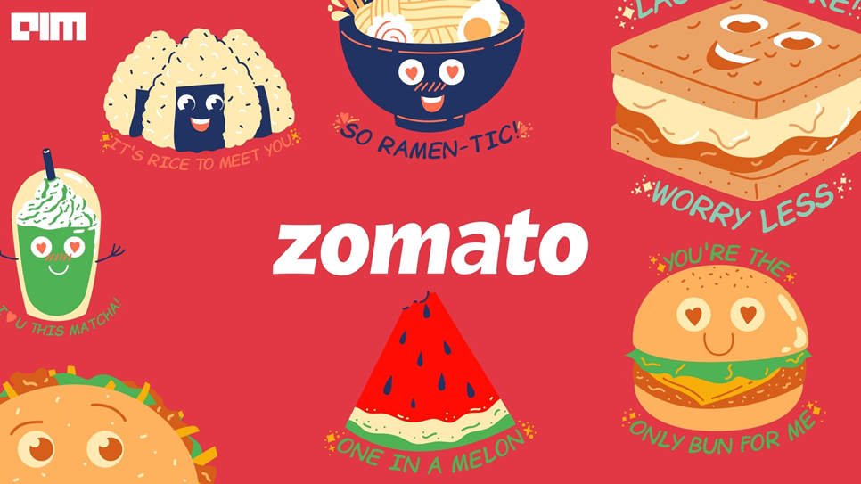

As a data analyst at Zomato, your primary responsibility is to analyze the provided dataset and extract meaningful insights. Begin by importing the dataset into Tableau and performing a data join operation to combine the "Location" and "Rating" tables based on a

suitable join key, such as the restaurant ID. This join will create a unified dataset that incorporates information about restaurant locations, cuisines, ratings, votes, and costs.

The analysis of the combined dataset can provide valuable insights to inform Zomato's strategy and decision-making processes. Start by examining the distribution of restaurants across different locations and cities. Create a table visualization in Tableau to showcase the number of restaurants in each city, sorted in descending order. This will help identify cities with a high concentration of restaurants and guide Zomato's marketing efforts and restaurant partnerships.

The dataset provided to you has the following two tables and their details are as follows:

Table – Location: The "Location" table contains information about various restaurants, including their names, locations, localities, cities, and cuisines. The table has the following columns:

ID: A unique identifier for each restaurant.
Name: The name of the restaurant.
Location: The specific address or area where the restaurant is situated.
Locality: The locality or district where the restaurant is located.
City: The city in which the restaurant operates.
Cuisine: The type of cuisine served by the restaurant. It may include multiple cuisines separated by commas.

Table – Rating: The "Rating" table provides details about the ratings, votes, and cost of various restaurants. The table includes the following columns:

r_id: A unique identifier for each restaurant.
Rating: The average rating of the restaurant, indicating customer satisfaction.
Votes: The total number of votes received by the restaurant.
Cost: The average cost of dining at the restaurant, providing an indication of price range.
Questions:

1. Import the file in Tableau and use the concept of Data Joining to join both the tables using an appropriate join.
2. Create a table showing number of restaurants in each city in descending order.
3. Create a heat map showing average rating of all the cities.
4. Create a chart to showcase average cost for each city.
5. Create a chart to visualize the number of branches (franchise) each restaurant has.
6. Create a packed bubble chart to give insights about the Top 10 restaurants which are available in various cities.
7. Create a bar chart to showcase best 5 restaurants by their average rating and location. The selection should be on the basis of a condition that the shortlisted restaurants have received at least 10 ratings.
8. Create four different sheets for KPIs corresponding to: Total Restaurants, Average Cost, Average Rating, and Total Votes.
9. Showcase any insight apart from the above asked questions.
10. Format all the sheets as per the Zomato theme.
11. Create a dashboard to use all the created insights. Create a dashboard action to select and filter things as per the selection made on Question Number (3) sheet in the dashboard. Use a filter of city in your dashboard as well.
12. Create a story to showcase all the sheets and dashboard.

